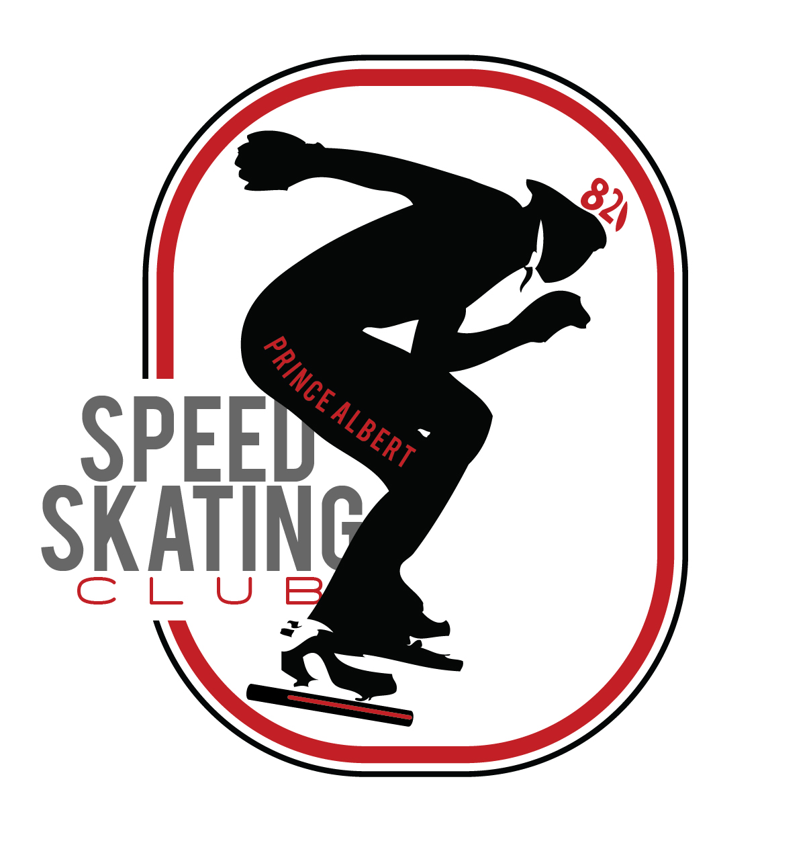
Speed Skating Program Fees for 2023-2024

Learn to Skate Program (ages 4 and up) PASSC Total Fee = $225.00

Speed Skating Program - Member Categories (based on Skater age as of June 30, 2023) | SASSA Fees | SSC Fees | PASSC  Ice Fees** | Total Fees
Learn to Skate & Active Start - Recreational | $8.00 | $10.00 | $207.00 | $225.00
Club Skater - Recreational | $13.00 | $10.00 | $400.00 | $423.00
Club Athlete | $32.00 | $10.00 | $400.00 | $442.00
Provincial Athlete | $61.00 | $47.00 | $400.00 | $508.00
National Athlete | $81.00 | $68.00 | $400.00 | $549.00
Speed Skating Canada Team Athlete* | $81.00 | $0.00 | $400.00 | $481.00
*Current athlete fee for National program is $1200.00 per season.

Annual Club Membership
- $20 per Associate Member – For insurance purposes, parents/guardians and volunteers going
on the ice MUST be a member. The club will cover fees for 1st person in the family.

___________________________________________________________________________________________________

Speed Skaters only
Equipment Rental
- Boots $30 per pair
- Short Track Blades $30 per pair
- Long Track Blades $30 per pair
- Short Track Skin Suit $40 each
- Cut Proof under layer $40 each **Males (12) / Females (11) and older

Damage Deposit

- $75 refundable damage deposit

