Return to Sport Protocol
Indoor Skating/Training
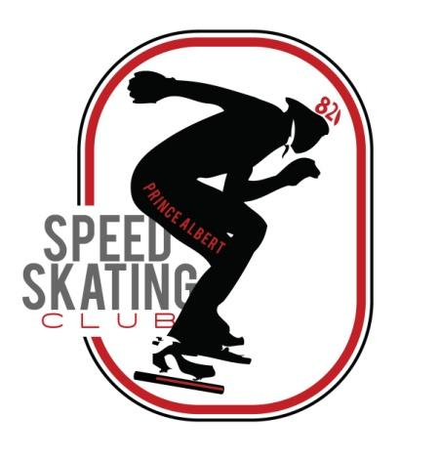
Prince Albert Speed Skating Club (PASSC)

These rules and policies are intended to enable a safe return to sport. These protocols are based on current Saskatchewan Health Authority (SHA) requirements and directives. These protocols may be updated at any time. Please be sure that you are referring to the most recent version of the Re-Open Saskatchewan plan located on the Government of Saskatchewan website.

OPERATIONS
1.1 Compliance with regulations
- All speed skating activities must adhere to all federal, provincial and municipal laws, regulations, by-laws and orders. This includes but is not limited to compliance with:
  - Physical distancing measures
  - Health and safety regulations
  - Size of permitted gatherings
  - Speed Skating Canada rules, policies and procedures
  - Saskatchewan Amateur Speed Skating Association rules

1.2 Administrative Activities
- All administrative activities should take place virtually wherever possible.
  - Registration (email forms and etransfers), Meetings

1.3 Facilities
- Art Hauser Centre is responsible for ensuring they meet government and public health guidelines. PASSC should satisfy themselves that the facility is operating in compliance with the advice, recommendations and instructions of public health officials.
1.4 Self-Assessment Screening
- All individuals taking part in club activities must self-screen in accordance with current public health guidelines before their arrival at each training session. Individuals must not attend any training sessions or club activities if they:
  - Exhibit any COVID-19 symptoms, such as a fever, cough, difficulty breathing, or other symptoms identified by health experts.
  - Have been in contact with someone with COVID-19 in the past 14 days
  - Are waiting on test results for COVID-19
  - Have returned from travel outside of Canada (must quarantine for 14 days at home)
  - Are considered a vulnerable or at-risk individual (over 70 years, weakened immune system or medical conditions such as heart disease, lung disease, cancer, etc)

1.5 Tracking & Contact Tracing
- Each, athlete, coach, parent, etc attending the skating training will be required to sign in at the start of each session.

TRAINING
2.1 Limitations to training group size
- Current phase – max. 30 people, including skaters, coaches, parents (spectators)

2.2 Physical Distancing
- Standing = 2 meters apart
- Skating = 3 meters apart

2.3 Personal Hygiene
- Individuals must follow the SHA guidelines
  - Wash/sanitize hands upon entry to site/facility or training area and at the completion of training
  - Wash/sanitize hands before and after accessing the storage room.
  - Keep hands off your face
  - Disinfectant wipes or hand sanitizer must be available at the training facility

2.3 Personal items
- Personal items such as water bottles, skate rags, etc. will not be shared.

2.4 Indoor Skating/Training
- Skaters must be able to maintain physical distancing at all times.
- Avoid: pack-skating, racing or relays. Indoor practices should include: individual technical drills, individual lap skating, pursuit races and Olympic-style skating.
- Training groups will be consistent. Keeping the same group week after week can help to mitigate transmission.

2.5 Shared equipment, cleaning
- Shared equipment should be sanitized after every practice if possible. In the case of protective padding, this may not be plausible.
  - Mats - the minimum number of people should help with mats (4-6). Each must wash their hands or sanitize prior to setting up and wear a mask while putting mats on. Wash hands after done set-up. Same procedure for take-down. NO GLOVES OF ANY TYPE PERMITTED.
  - Pucks- One coach only handles the pucks. Sanitizer should be used after handling pucks during or after the practice. Everyone on the ice must sanitize or wash hands prior to practice.
  - Straps, etc.: until we reach stage five, no straps will be used on the ice.
  - If a skater contacts the mat, it will be sanitized after the impact.
  - Sharpening Kits – each family will have a kit that they are to use for the duration of the season. If one needs to be shared, prior to use AND after use, everything needs to be sanitized (hands, skates, jig, wrenches etc)

2.6 Coaching
- All coaches must maintain 2m distancing

2.7 Change rooms
- Skaters are encouraged to come to practices and leave already dressed in their skating attire to minimize time in the dressing room.
- You will only be allowed into the dressing room 15 min. prior to skate time and encouraged to leave immediately following your skate. No dawdling in the change rooms
- Adults (masks recommended) are allowed in the change room only if their child needs help getting dressed.

2.8 Storage Room
- The storage room will be locked and off limits during ice times. If you need something in storage you will have to ask Lambert or Nicole to retrieve it for you.

2.9 Entry and exit to/from the ice
- Distancing rules apply

3.0 Spectators
- Limit accompanying parents, guardians or other spectators for each skater to ONE if possible. MUST follow group size limitations. If the limit is exceeded, members will be denied access to facility.
- Spectators must remain at least 2m apart and may choose to wear a face mask.
- Seating is limited to the sections on each side of dressing room 1.

3.1 First Aid
- In the event that first aid is required to be administered during an activity, all persons attending must first sanitize hands, put on a mask and gloves.
- Sanitizer, masks and gloves will be provided but it is encouraged that each person entering the facility also has access to their own.

Prince Albert Speed Skating Club Updated August 16, 2020

