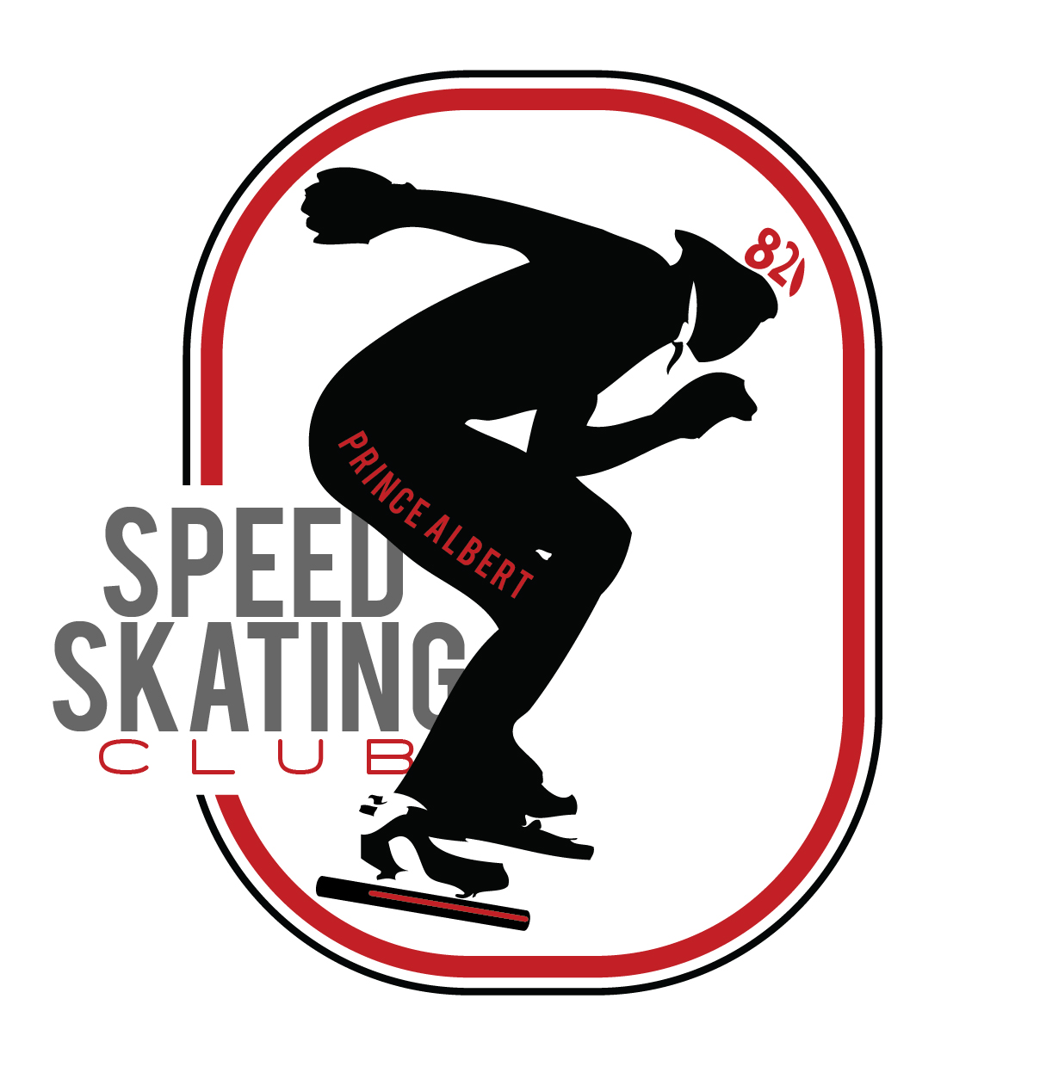
Speed Skating Program Fees for 2021-2022

Learn to Skate Program (ages 4 and up) PASSC Ice Fees = $185.00

Speed Skating Program - Member Categories (based on Skater age as of June 30, 2021) |  | SASSA Fees | SSC Fees | PASSC  Ice Fees** | Total Fees
Active Start – Recreational – under 6 yrs old |  | 8.00 | 6.50 | 360.00 | $374.50
Active Start – Competitive – under 6 yrs old |  | 8.00 | 43.00 | 360.00 | $411.00
FUNdamentals -- Males 6-9; Females 6-8 |  | 32.00 | 43.00 | 360.00 | $435.00
Learn to Train -- Males 10&11; Females 9&10 |  | 61.00 | 43.00 | 360.00 | $464.00
Train to Train – Males 12 / Females 11 |  | 61.00 | 43.00 | 360.00 | $464.00
Train to Train – Males 13 / Females 12 |  | 61.00 | 43.00 | 360.00 | $464.00
Train to Train – Males 14 / Females 13 |  | 79.00 | 43.00 | 360.00 | $482.00
Train to Train – Males 15 / Females 14 |  | 79.00 | 43.00 | 360.00 | $482.00
Junior B | 15 or 16 years old | 79.00 | 43.00 | 360.00 | $482.00
Junior A | 17 or 18 years old | 79.00 | 43.00 | 360.00 | $482.00
SENIOR/MASTER | 19 years and older | 79.00 | 43.00 | 360.00 | $482.00
Recreational | Older than 6 yrs old | 13.00 | 21.50 | 360.00 | $394.50

Annual Club Membership
- $20 per Associate Member – For insurance purposes, parents/guardians and volunteers going
on the ice MUST be a member. The club will cover fees for 1st person in the family.

___________________________________________________________________________________________________

Speed Skaters only
Equipment Rental
- Boots $30 per pair
- Short Track Blades $30 per pair
- Long Track Blades $30 per pair
- Short Track Skin Suit $40 each
- Cut Proof under layer $40 each **Train to Train and older

Damage Deposit

- $75 refundable damage deposit

